6.40: a) From Eq. (6.14), with 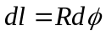,
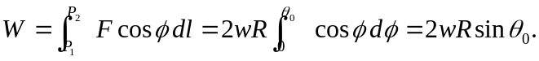
In an equivalent geometric treatment, when 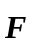 is horizontal, 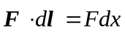, and the total work is 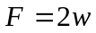 times the horizontal distance, in this case (see Fig. 6.20(a)) 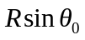, giving the same result. b) The ratio of the forces is 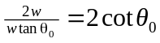.

c) 